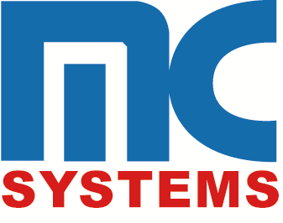
a

Research Analyst

ABOUT THE OPPORTUNITY
Management Control Systems Limited (MC Systems), a leading provider of software development services, seeks to identify a suitably qualified and experienced candidate to fill the position of Research Analyst. The Research Analyst will be responsible for the creation of new intellectual property for new and existing products and services in alignment with the strategic objectives of the company. The role is multi-disciplinary and calls for good skill sets in research, business analysis, technology awareness, defining solutions, software development, project management, presentation, creative thinking and critical thinking.
JOB CATEGORY: Technical

KEY RESPONSIBILITIES
- Conduct research relating to market opportunities and technology trends in local, regional and international markets
- Gather data on competitors and analyse prices, sales, and methods of marketing and distribution
- Research and prepare technical proposals based on market trends and potential opportunities
- Effectively communicate concepts and proposed solutions to relevant stakeholders
- Assist with developing business cases
- Manage and execute the ideation process
- Analyse current business processes and propose enhancements for improved user experience and efficiency
- Develop proof-of-concept solutions
- Liaise between product owners, development teams and other stakeholders involved in the execution of a project
- Document requirements that enable a solution to be developed and tested
- Formulate feature and technical roadmaps for existing products
- Provide oversight and guidance to software delivery teams executing on R&D projects and proofs-of-concept

REQUIRED QUALIFICATIONS & EXPERIENCE
- Bachelor’s degree in Information Technology
OR
- Bachelor’s degree in Business Administration with supporting I.T. studies

PERSONAL ATTRIBUTES
- Excellent analytical, mathematical, and creative problem-solving skills
- Excellent listening, interpersonal, written, and oral communication skills
- Logical and efficient, with keen attention to detail
- Ability to effectively prioritize and execute tasks while under pressure
- Team-oriented and collaborative
- Strong customer service orientation

Interested applicants are being invited to forward an updated résumé and cover letter as one document to:

application@mcsystems.com

Subject Line: “Research Analyst – MC Systems”
Cover letter and resume to be titled: FirstName_LastName_Research Analyst

Attn: HR Business Partner
Group Human Resource Development
15 Braemar Avenue, Kingston 5, Jamaica W.I.
CLOSING DATE FOR APPLICATIONS: JULY 19, 2019
We thank all candidates for responding, however, only those short-listed will be contacted.

